The First Step:

A Basic Guide to Civic Engagement

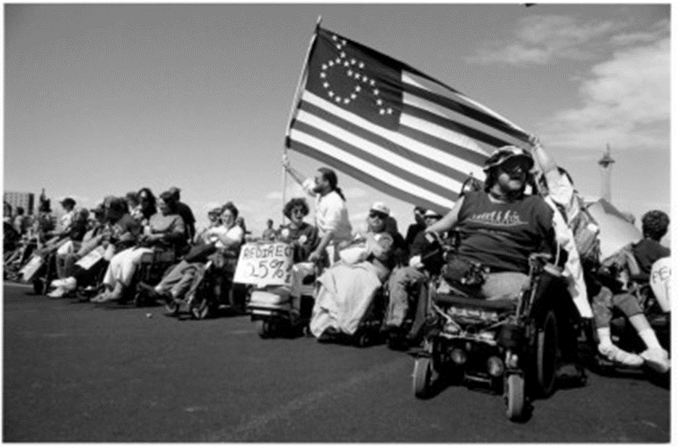

**Table of Contents**

What is Civic Engagement…………………………………………………………………………………………………………… 2

How Do I Get Involved……………………………………………………………………………………………………………... 3-4

How Do I …………………………………………………………………………………………………………………………………. 5-6

Templates

How to Address Letters…………………………………………………………………………………………………………….7

Letters and Emails to Government Officials…………………………………………………………………………….. 8

Phone Calls to Government Officials & Speaking at Group Meetings .…………………………………... 9

Letter to the Editor……………………………………………………………………………………………………………………10

Basic Steps in Texas Legislative Process…………………………………………………………………………………11-12

Resources………………………………………………………………………………………………………………………………….. 13



*HAVA 7/2017*

**What is Civic Engagement?**

When people talk about “civics” they mean your local (city and town) government staff, events, and laws. The word “civic engagement” is used when talking about issues of public concern. It also means learning how to be a good citizen by using skills such as voting, knowing and following laws, etc. How you choose to take part in civic engagement is up to you. There are several ways you can become active in your community. Some of the most common ways are listed below:

•Community service • Helping people register to vote

•Writing/calling local officials • Writing letters to the newspaper

•Participating in committees or neighborhood/town/city/county activities • Voting

•Speaking out when you agree or disagree with something • Volunteering on a campaign

**Why Get Involved**

Being involved in the decisions made for your community is the best way to make sure your interests and opinions are being represented, and are shown in rules in that are made. Chances are if you, or one person, feels that way, a bunch of other people feel that way as well. Letting people know what you think about things, may also mean you are speaking up for other people as well.

In your town, county, and state, there are several smaller committees, or groups, that exist so they can provide more one-on-one work with community members. This one-on-one work can include an opportunity to talk about topics that you find important; giving suggestions to your town officials about problems directly related to where you live. This allows for a chance to gather everyone’s opinion and submit it to larger groups. Getting involved with these ‘grassroots’ groups is one of the (best) ways to get your voice heard.

One of the main roles United States citizens play in government is to hold our public leaders and decision makers accountable. This type of government gives our country a unique difference from other governments/countries. Civic and political participation is important so that decisions are not made by a few people. It is a form of self-advocacy. Participation by the individuals means we get to define what our rights and freedoms are. Holding your government accountable means being a good citizen.

Everyone has a different reason for being (civically) involved in their community. You must find out what your reason is.

**How Do I Get Involved….**

There are several ways for you to get involved in helping your community and voicing your opinion. Some of the most common ways people interact with their government is through voting, community service, helping people register to vote, contacting your elected officials, writing letters to the newspaper, volunteering on a campaign, participating in different (community) groups, speaking out when you disagree with something, self-advocacy. Remember, it is your choice on how to do it, there is no one way to get involved. Whatever works best for you.

1. ***Voting…*** In Texas, a person is eligible to vote if they are 18 years of age or older; a citizen of the United States; not a convicted felon (criminal) (unless you are done with your sentence); have not had your ability to vote taken away by a judge through guardianship.
2. ***Registering people to vote…***Although you don’t need to be a volunteer deputy registrar (VDR) to assist people with voter registration, becoming deputized as a VDR provides more training and allows you to give people a receipt to prove they registered.

What is a volunteer deputy registrar (VDR)?

Volunteer deputy registrars are given the responsibility of officially registering voters in the State of Texas. They are appointed by county voter registrars and charged with helping increase voter registration in the state.

How do I become a VDR?

Contact your county voter registrar. The county voter registrar will explain your county’s training requirements for becoming a VDR, which usually involve attending a free 1-2 hour training session. Once you have finished training, the voter registrar will give you a certificate of appointment and give you a receipt book (some counties have voter registration forms with tear-off receipts). You must be at least 18 years old, a U.S. citizen, and a Texas resident. All of the qualifications are listed in the online Texas Secretary of State Texas Volunteer Deputy Registrar Guide.

What are the main duties of a VDR?

A VDR may handout and accept a voter registration application forms from any eligible resident of the county in which you are deputized. A VDR may also hold voter registration drives. VDRs also may distribute and accept applications from voters who wish to change or correct information on their voter registration certificate (e.g., name or address). VDRs are required to review the application to see it is complete in the applicant’s presence, provide a receipt, and deliver the applications within the required time to the county voter registrar office. There is no minimum time commitment required.

Can I still conduct voter registration if I am not a VDR?

Absolutely!

1. Use the self-addressed postage-paid form found at county election offices.

2. Print a voter registration application, have clients fill out, sign and mail in to their county

election office (requires postage).

3. You may review the application to see if it is complete. Unless you are a VDR, you MAY NOT

collect completed forms. Neither VDRs nor non-VDRs may mail a completed form or provide

an envelope or postage.

1. ***Serve as a Poll Worker***

What does an election worker/poll worker do exactly? Their primary job is to make sure the voting process (in their precinct) runs smoothly. Duties can include confirming a voter’s ID/ credentials, giving out ballots, keeping track of all equipment and votes, as well as making sure all voting laws are followed throughout the entire election process. A great part of being an election worker is that you don’t have to be a government official; the only requirement is that you are a registered voter in the county in which you work.

What’s even better is that you can earn money while doing this! While some counties pay different amounts, the average wage for a poll clerk in Texas is approximately $8.50 an hour. This is a great work opportunity if you can only work part time hours, are limited to how much money you can earn, are trying to build some job experience, etc.

How do you sign up? First, contact your county elections office and let them know you would like to serve as an election worker. You will have to attend a training for election workers put on by the elections office. Each county may have a different way of doing things, so be sure to ask the election office staff what next steps you need to take. If you need help finding the election office’s contact information, you may visit this website (http://www.sos.state.tx.us/elections/voter/county.shtml) to find the contact information for each county’s election office. You can also talk to a staff person at your independent living center to see if they can help you.

***IV. Community Service…***

Community service means to volunteer your time to a group or cause that you believe in. This is an activity that you do not get paid for, but you will get some good work experience and you’ll feel good because you helped with a cause that you believe in. Volunteer options can include: helping at your local library; helping at an independent living center; picking up litter on the side of the street; participating in your local REV UP chapter; helping people register to vote; helping at your church; participating with your local League of Women Voters chapter; walking your neighbor’s dogs; volunteering with a food drive; getting people to sign a petition for a cause you believe in; etc. Volunteering can be something that makes the area you live, and places you visit, a better place.

**How Do I….**

1. ***Contact My Elected Official***

You can call, email, or write a letter to your legislator. To speak to your representative or senator in person, contact their office to make an appointment. There are different opinions about which form of communication is the most effective but most people agree that calling or writing your representative is the best way to let them know what you’re thinking.

If calling a representative's office, your first contact will almost always go through the main office number. Staff Assistants or interns usually work these phones. While these staff members are quite capable, they are usually not experts in specific issues. (See template section for phone call)

Whenever possible, make your calls, send your emails, and schedule your meetings for times when your elected official is not in session. Because elected officials are very busy, it is probably best not to call or schedule appointments on Fridays or Mondays.

No matter how you choose to contact your representative, remember to be polite and respectful, be brief, and be prepared.

*\*\*SEE TEMPLATES IN BACK FOR GUIDANCE ON HOW TO SPEAK WITH YOUR ELECTED OFFICIAL\*\**

1. ***Talk in Front of Group Meetings***

If you are interested in speaking at a city council meeting, you are usually required to register with the city council representative’s office or the city clerk’s office ahead of time. Registration information will usually include the date of the meeting you want to speak at, the location of the meeting, your name and contact information. Contact your local City Clerk for more information.

Guidelines to follow when speaking:

1. Introduce yourself, state the city where you live and any relevant associations. If you are speaking for yourself but are a member of a group, say so.

2. State your position clearly and briefly explain your position.

3. Thank the group when you are done making your comments.

\*\**SEE TEMPLATE SECTION IN BACK FOR GUIDANCE ON HOW TO SPEAK AT CITY COUNCIL MEETINGS\*\**

1. ***Find Out About Community Meetings***

So how do you find out about everything that is happening? Most newspapers will have a community section which lists many community group meetings, activities, events going on for that week or month. If you have access to the internet, many groups have a Facebook account that give event details. Libraries and community centers are also good sources of community information. Ask a librarian or community center staff person about where you can find this information.

Call- contact a group you are interested in and see when their next meeting is.

Ask Around- do you have friends that are involved with things you’re interested in? Ask them when the next meeting is; how can you get involved? Staff members at ILC’s may have some information to offer, or could assist you finding out information.

1. ***Write a Letter to the Editor***

A letter to the editor is a written way of talking to a newspaper, magazine, or other regularly printed publication. Letters to the editor are generally found in the first section of the newspaper, or towards the beginning of a magazine, or in the editorial page. You may want to write a letter to the editor because you have a strong opinion about something you just read; feel the need to point out a mistake in the article; or you feel strongly about an issue and you want to let people know what you think.

*\*\*SEE TEMPLATE SECTION IN BACK FOR GUIDANCE ON HOW TO WRITE A LETTER TO THE EDITOR\*\**

**V. *Voice My Opinion on Social Media***

“Social media” is any website or online resource that you can use to talk to or share ideas with other people. There are two major social media websites that you can use to help contact your elected officials. They are called Facebook and Twitter. Social media can be used to connect with other people who care about the same problems that you do. You can also use it to spread the word about problems you care about so that other people can learn about them. Or, to learn about problems you didn’t know about before.

Facebook is the most-used social media site by American adults. On Facebook, you can make a private page for yourself, called a profile, and post whatever you want on it. This helps people share things that they care about. Facebook is a good tool for many reasons. You can tell people about topics that are important to you on your Facebook profile, or in a Facebook group. Facebook groups and pages reach a lot of people in a short time. You can create a page if you are a part of an advocacy group. You can use the group to let people know what you are doing and give them chances to get involved. You can also follow pages or join groups for other organizations to learn what they are doing. Elected officials also sometimes have their own Facebook pages. You can post on these pages how you feel about important issues and see what other people in your area think.

Facebook is also a great tool to work together with other groups. That’s because it can be easier to send a message on Facebook than to make a phone call or meet up in-person. You can organize projects like letter-writing or phone call campaigns to your members of government.

Twitter does not have pages or groups like Facebook. Each person on Twitter just gets their own profile. On Twitter, posts are called “Tweets”, and posting is called “Tweeting”. Everything that someone tweets has to be 140 characters or fewer, which is about 25 words. It helps make sure everything people post is short and to-the-point.

You can “follow” people on Twitter to see what they are saying. If you want the people that follow you to see a certain tweet from someone else, you can “re-tweet” it. Re-tweeting something makes the Tweet show up on your own Twitter page.

Re-tweeting is easy to do. This makes it easy for important Tweets to spread around Twitter really quickly. Many elected officials have a Twitter account. Following them can help you stay informed about what they are doing and spread the word to other people who may care.

**Templates**

How To Address Letters

*Technically anyone elected to office in the U.S. in a general election is entitled to be addressed as The Honorable*

<http://www.formsofaddress.info/FOA_home.html>

CITY COUNCIL: The Honorable (City Council Member’s name)  *Dear Mr./Ms. (last name),*

Council Member, (Name of City) City Council

Xxxx Main Street

City Name, TX zip code

STATE GOVERNOR: The Honorable (Full name) *Dear Governor (last name),*

Governor of (state)

(Address)

STATE REPRESENTATIVE: The Honorable (name of State Representative) *Dear Representative (last name),*

Texas House of Representatives

(Address)

STATE SENATOR: The Honorable (name of State Senator) *Dear Senator (last name),*

Texas Senate

(Address)

U.S. STATE REPRESENTATIVE: The Honorable (full name) *Dear Representative (last name),*

U.S. House of Representatives

(Address)

U.S. STATE SENATOR: The Honorable (full name) *Dear Senator (last name),* U.S. Senate

(Address)

**Letters and Emails to Government Officials**

(Enter Date Here)

The Honorable____________

(Title of person), (Governing body)

(Address)

(Town, State, Zip)

Dear _______________,

My name is ___________________, and I am one of your constituents. I am writing you today about _________. I want to let you know that I (support/do not support) this (issue/law/bill). This issue is important to me because (explain why it is important to you).

*Can explain in further detail why you are affected by this issue and why your representative should know how you feel. Be specific about what you would like the person to do (i.e., vote no on this issue, help out, write new laws, etc).*

Thank you very much for your time and any efforts you take to increase ____________________.

Sincerely,

Your name

Your Address

**Phone Calls to Government Officials**

1."Hello, my name is _____ and I'm calling from ____in ______ (state/area/town) regarding ___ issue.

2.Would it be possible to speak with or leave a message for Senator/Representative_______'s Legislative Aide or Legislative Correspondent who specializes in this issue?

*Usually, you will need to leave a message for the appropriate staffer. Always follow proper message protocols when doing this:*

Leave your name, your number, your reason for calling, and close it with a request that they call you back.

**Speaking at Community & City Council Meetings**

Good Evening/Afternoon,

My name is ________, and I live in (name of city). *List any groups that you are a part of.* I am here in support/opposition to ________________. I do/do not support this issue because of *(list your reasons here)*.

Thank you for your time and the opportunity to speak with you.

**Letter to the Editor**

Date

Name of media outlet or publication

Attention: Dr./Ms./Mr. editor’s first name and last name* or Editor

Address 1

Address 2

City, State/Province, Zip/Postal Code

Dear (Dr./Ms./Mr. last name of editor or Editor):

**Introduction**

*State your reason for writing here. If you are responding to articles or editorials by the media outlet, use the first sentence to reference the name of the publication (in italics), the title of the article, author’s name and date when it appeared.*

**Case**

*State your case here. Include facts, references or research here to establish credibility. Mention your expertise on the issue. Keep length in mind. Acceptable letter length will vary. Look at the newspaper’s or periodical’s letters section to get a feel for an appropriate length. Include a call to action, asking readers to follow up with some activity, such as calling on policymakers to address the issue.*

**Conclusion**

*End with a strong, positive statement in support of your case.*

Sincerely,

(Writer’s signature)

Name of writer

Writer’s title

Writer’s organization’s name and address

Daytime contact information

*\*Find the editor’s name on the masthead of the publication.*

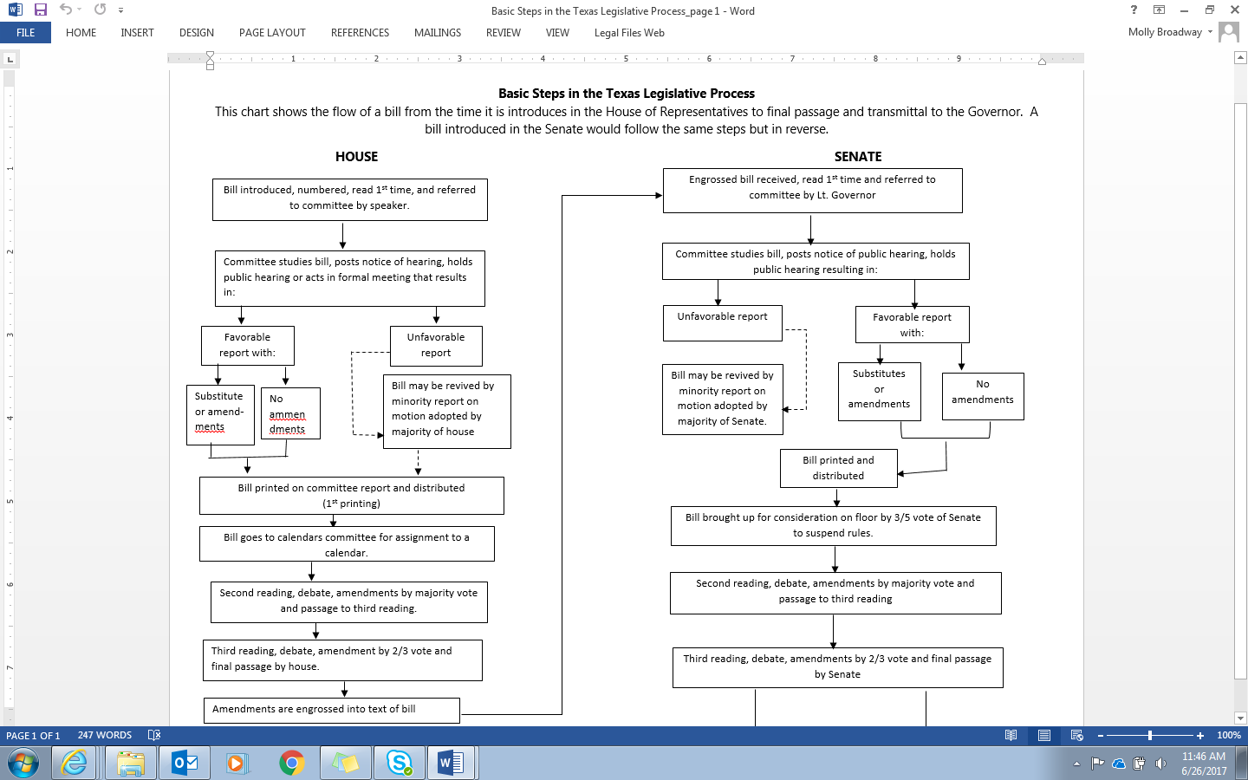

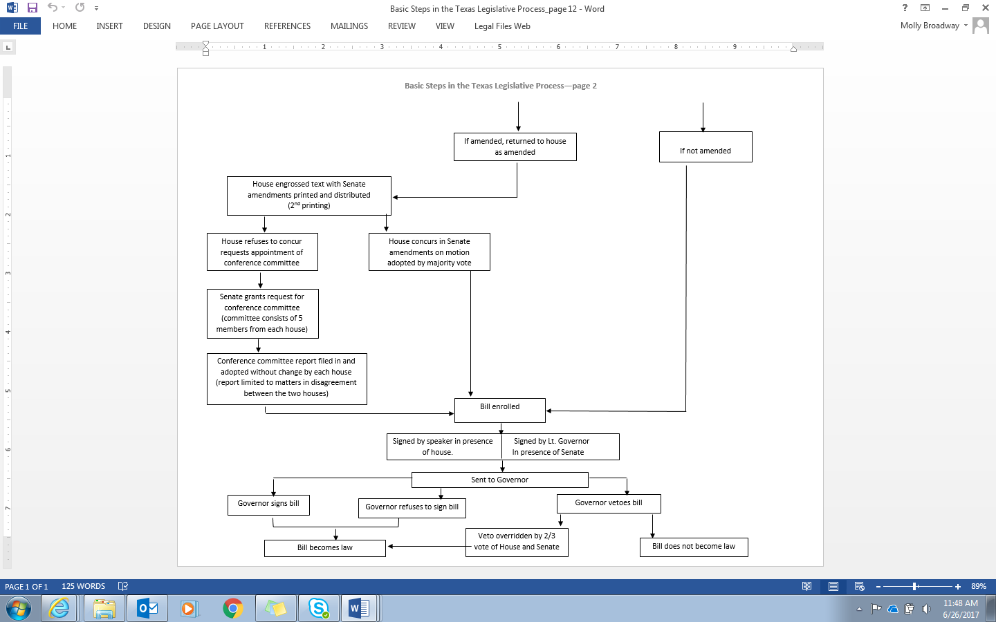

**Resources**

* **Citizen Handbook: How the Texas Legislature Works**

<http://www.senate.texas.gov/_assets/pdf/Citizen_HBook_Web_2015.pdf>

* **American Association of People with Disabilities (AAPD) Voter Resource Center**

<http://www.aapd.com/our-focus/voting/voter-resource-center/>

* **How to find your State Representative/Senator** <http://www.fyi.legis.state.tx.us/Home.aspx>
* **Personalized Ballot** <http://www.vote411.org/ballot>
* **How to Make a Comment at a City Council Meeting**

<http://www.wikihow.com/Make-a-Public-Comment-at-a-City-Council-Meeting>

<http://www.wikihow.com/Speak-In-Front-of-Large-Groups-of-People>

* **Disability Organizing 101 and Beyond** <http://freeourpeople.net/disabilityorganizing101andbeyond/?page_id=17>
* **The Americans with Disabilities Act** <https://www.ada.gov/>
* **Register, Educate, Vote & Use your Power (REV UP)** [revuptexasvote@gmail.com](mailto:revuptexasvote@gmail.com)

1208 Marshall Lane, Austin, TX 78703 (512) 431-4085

* **Disability Rights Texas** [www.drtx.org](http://www.drtx.org)

2222 W. Braker Lane, Austin, TX 8758 Voter Rights Hotline: 1-888-796-8683

* **Coalition of Texans with Disabilities** [www.txdisabilities.org](http://www.txdisabilities.org)

1716 San Antonio St., Austin, TX 78701 (512) 478-3366

* **The ARC of Texas** [www.thearcoftexas.org](http://www.thearcoftexas.org)

8001 Centre Park Dr. Ste. 100, Austin, TX 78754-5118 (512) 454-6694

* **Texas State Independent Living Council** <http://www.txsilc.org/>

4319 James Casey Street Suite 100, Austin Texas 78745 (512) 371-7353

* **Texas Advocates** <http://arctx.convio.net/site/PageServer?pagename=TXA_homepage>

8001 Centre Park Dr. Austin, TX 78754 1-800-252-9729, Ext. 112

* **ADAPT Texas** <http://adaptoftexas.org/>

1208 Marshall Lane, Austin, TX 78703 (512) 442-0252

*\*Information contained in this toolkit has been adapted from the following resources: The League of Women Voters-Texas Chapter; Self Advocates Becoming Empowered (SABE); Disability Rights Texas Easy Voter Guide;* [*www.votility.com*](http://www.votility.com)*; Minnesota State Legislature; Texas Legislature Citizen Handbook; Autistic Self-Advocacy Network.*